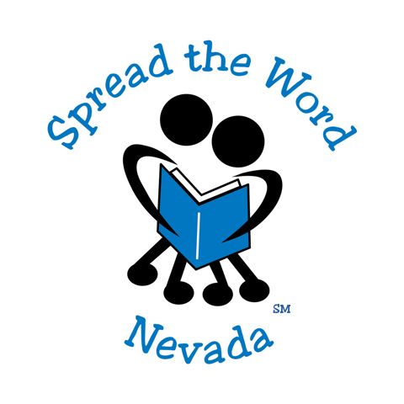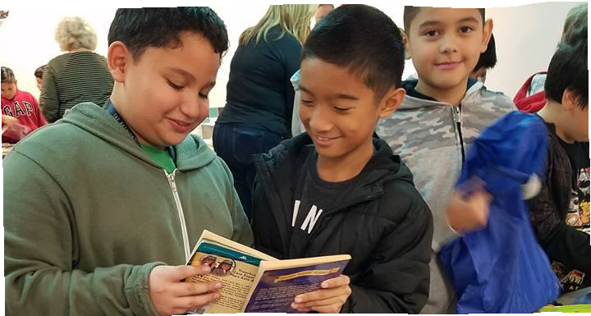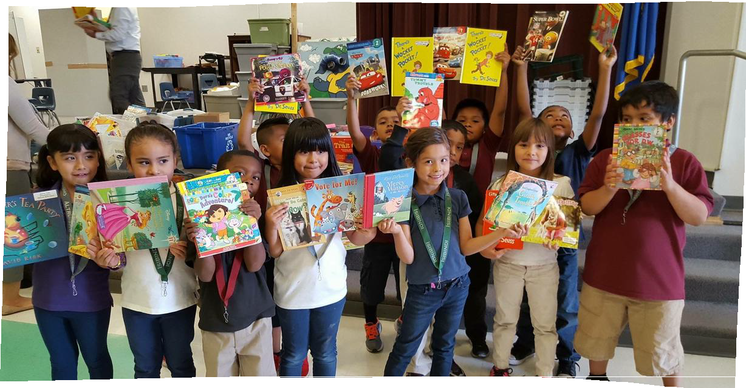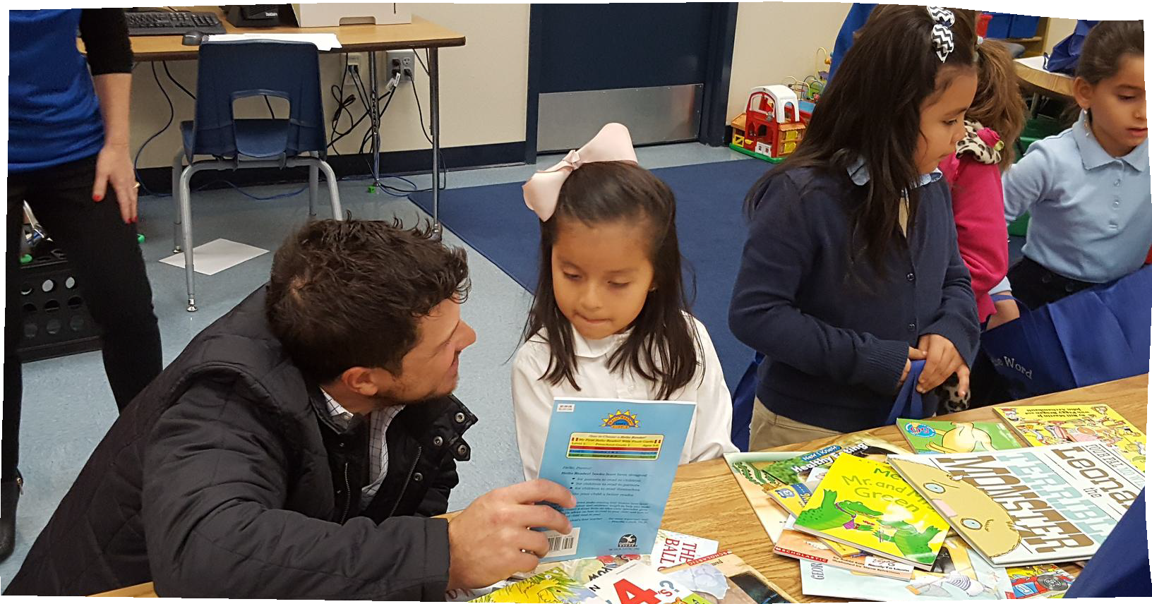G O T B O O K S ?
DONATE A BOOK, CHANGE A LIFE

[NAME OF DRIVE]
BOOK DRIVE

Bring in your new or gently used books to support Spread the Word Nevada, a literacy nonprofit dedicated to placing books in the hands of disenfranchised youth.
[Date] • [Time] [Location] [Contact]

Info:
PreK-5th grade reading levels preferred No encyclopedias, coloring books or books with a library's dewey decimal tag on them

Spread the Word Nevada is a 501(c)3 nonprofit dedicated to advancing childhood literacy within low-income communities. Since 2001, STWN has distributed more than 5.7 million books to at-risk youth, served 632,000 students and adopted 62 schools. Visit www.SpreadtheWordNevada.org to learn about how you can positively impact a child one book at a time.

